**Relax in the lap of natural beauty Darjeeling**

**Culture and Traditions**

The culture of Darjeeling is quite diverse and unique. Darjeeling is picturesque city located the state of West Bengal. The city is multi ethnic and multi cultural, It includes a variety of indigenous practices and festivals, owing to its mixed ethnicity of population and their various customs and traditions. *Lepchas* were the original inhabitants of Darjeeling*. Nepali Gorkhas* constitute the majority of population of Darjeeling today. Many of the Nepali Hindus as well as the various Buddhist ethnic groups have their own distinct languages and cultures, and yet they share a largely harmonious co- existence.

The predominant religions of Darjeeling are Hinduism and Buddhism followed by Christianity. Certain Buddhist ethnic groups celebrate their new year called *Losar*, in January\February.

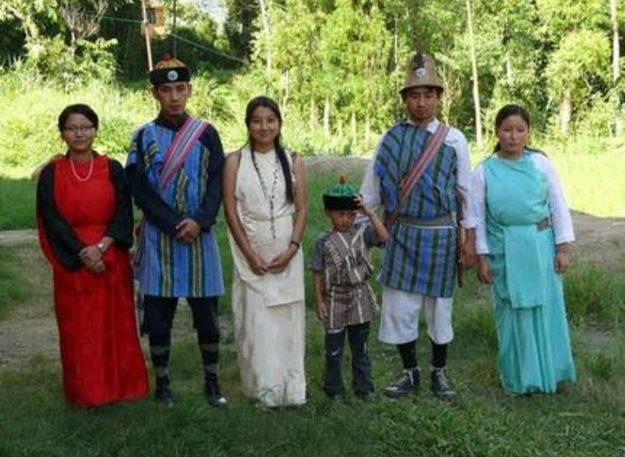

Festival contours the cultural synthesis of Darjeeling. Apart from the main festivals, the diverse ethnic populace of the town also celebrates several local festivals along with Losar. The Khambus community celebrates their annual *Sakela* festivals of *ubhauli and udhauli*. *Deusi and Bhaileni* are songs performed during the festival of Tihar.

Houses are decorated and spirits start building up when the festivals commence. Lasting two weeks it consists of Lakshmi puja, Bhailo and Bhai tika. There are robust folk dances, the most popular of them all is the scintillating *Maruni.* Gay folk songs fill the air with *jhowre* relating to lover, and the *juhari* which throws questions and answers between the love sick couple. It looks like people save all their energy for these two weeks which are filled with great rejoicing.

*Darjeeling Carnival,*  that happens at the end of years, is a cultural extravaganza that celebrates the region's vibrant and varied cultures and traditions. It is a ten-day carnival held yearly during the winter, with the portrayal of the Darjeeling hill’s musical and cultural heritage as its central theme. They have a rich heritage of folk and dances which are the major integral part of their lives.

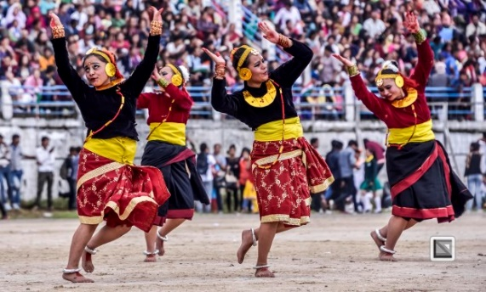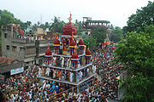

Darjeeling is regarded as a niche for musicians and music admirers. Singing and playing musical instruments are common pass times among the resident population, who take pride in traditions and their role of music in cultural life.

The town welcomes everyone with warm heart and hospitality offered by the hotels in Darjeeling is just unmatched. Before Independence, Darjeeling acted as a summer retreat for the British officials and also as sanatorium for the British soldiers for its scenic beauty. Darjeeling has been one of the favourite tourist destinations in India. The amicable nature and breath taking beauty continues to attract more and more people every year.

All these provide a regional distinctness to Darjeeling's local culture from the rest of India.

**Rukhba Anham**

**PYEE**

**MA201387**

**Scenic view**

Perched at a height of 2200 meters, the lively hill town of Darjeeling is tucked away in West Bengal lively winter spirit. Although it is popular with travellers throughout the year, this is perhaps the one time when the joy radiates from people here without bounds. Surrounded by lush green tea plantations, the hill station is known to offer spectacular views of the jagged white Himalayan peaks and the snow-clad peaks of Kanchenjunga - the third highest mountain in the world. With its charming toy train, colonial-era architecture, stunning Buddhist monasteries and vibrant cafes, Darjeeling surely knows how to floor you in more ways than one.

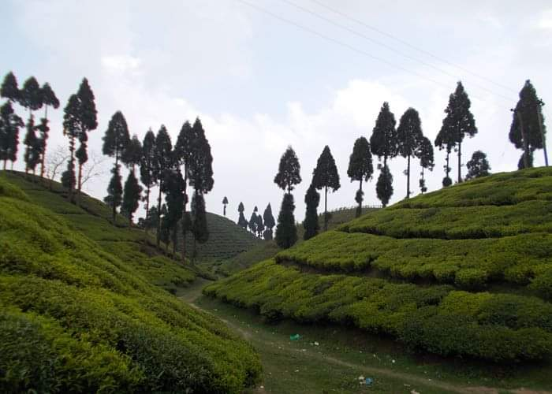

**Best Time to visit Darjeeling :-**

If you’re heading out for a family or solo trip to explore Darjeeling’s dreamy destinations, then here you can find this hillside beauty’s changing seasons and choose the best time to visit in Darjeeling. One of the most popular hill stations in India, known as ‘Queen among the Hills', Darjeeling is loved for its diverse ethnic culture and scenic beauty which is bound to leave you awestruck. The serene and cool weather adds to the beauty of the place and makes it more mesmerizing. Someone can visit Darjeeling throughout the year as the weather remains cool and pleasant. However, you might want to reconsider your travel plans during the monsoon season as landslides are common in this time. So-

* Between March to May- during Summer season
* Between October to November- Autumn, sometimes during Winter season.
  + Both these times, the temperature is pleasant cool and the sky is usually clear, offering spectacular views of the Kanchenjunga snow

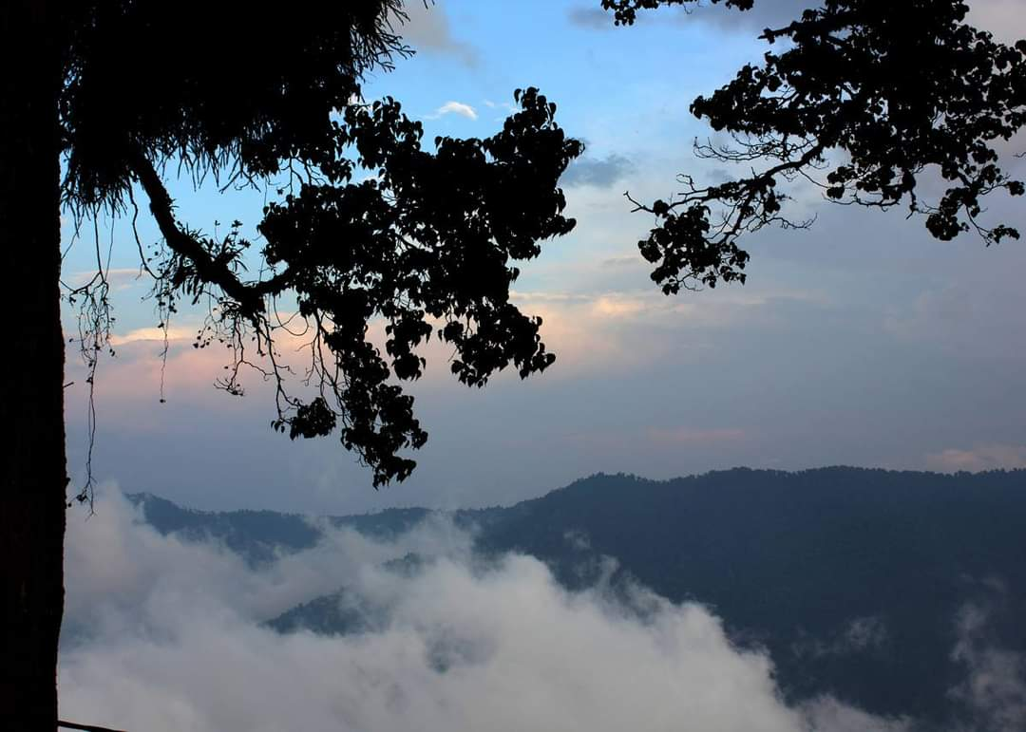

**Darjeeling in Summer: from April to June:-**

The temperature is mild during the summer season. It is usually around 25°C and it is indeed the best time to visit Darjeeling. Summer months from April to June are great for Darjeeling tourism as the climate is at its best during these months and there are so many outdoor activities to explore. Don’t forget to check out the mesmerising sunrise on Tiger Hill and witness the beauty of Kanchenjunga, the highest mountain peak in India. The Barbotey Rock Garden is also a great place to visit during summers in Darjeeling. Extreme cold slowly fades away and the weather becomes tranquil and pleasant by the end of March. One of the best seasons to visit Darjeeling is during summer. Colourful magnolia and rhododendrons bloom aplenty throughout the season. Taking a stroll in the streets of Darjeeling during summers is an unforgettable experience in itself. Some light woollens and shawls are all that you will need in this season. The evenings won’t be chilly and so you can easily explore the surroundings by walking.

**Darjeeling in Monsoon: from July to September:-** Starting from July onwards, heavy monsoon is usually witnessed in Darjeeling. Monsoons are great but visiting Darjeeling during these months might prove to be inconvenient due to roadblocks in every nook and corner along with frequent occurrence of landslides. However, if you have already made plans to visit Darjeeling during the monsoon months, you will fall in love with the lush-green surroundings drenched in rain which make for some amazing photographic shots. On the other hand, by the time it is September end, there is lesser rainfall. So you can definitely consider planning your Darjeeling trip during this time. The places to stay in Darjeeling, like hotels and resorts offer lucrative deals during monsoons as it is considered to be the off season. This means you can book a luxurious hotel at an unbelievably reasonable price and enjoy your pleasant monsoon stay.

**Darjeeling in Winter: from October to March:-**

Winter season is super chilly in Darjeeling as the temperature ranges between 2°C and 7°C during this time. It usually begins from October and lasts till March, but can be the best time to visit Darjeeling and enjoy its snowy and pristine beauty. You can get a spectacular view of the snow-capped mountains and enjoy the solitude since not many tourists flock here in this season. Imagine spending quality time with your loved one in Darjeeling during winters.

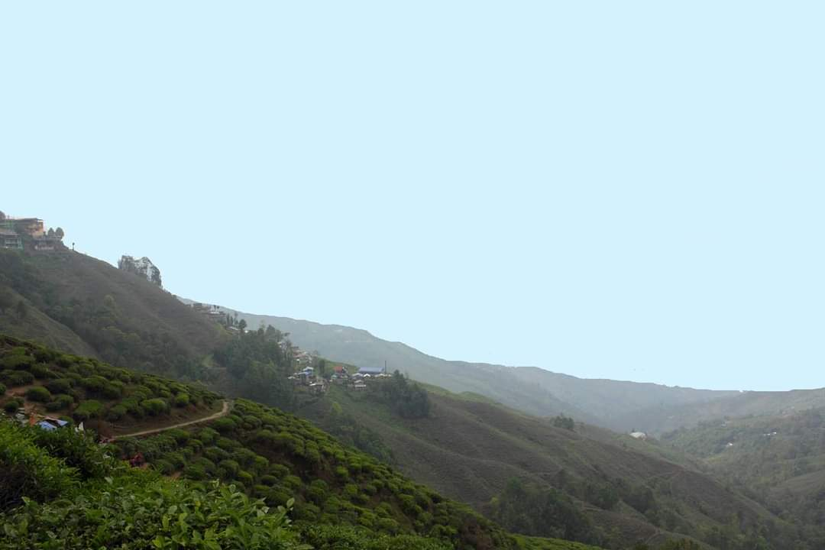

You shouldn’t forget to carry your woollen clothes if you are planning to visit Darjeeling anytime between December and February. Yet another great attraction in Darjeeling is the wide variety of local ethnic foods. Due to the prevalence of diverse cultures, you get to taste authentic local food from several ethnic groups like Tibetan, Nepali, Bengali, and so on. The world famous aromatic Darjeeling tea, local handmade snacks like Churpee (made out of Yak’s milk) and local drinks like Tongba (a local beer) are simply delicious and lip-smacking good. Darjeeling is also renowned for delicacies like Thukpa, momos, alu dum, traditional Nepali thali, Dalle, kakra ko achar and kinema, naga cuisine,shaphalay, sael roti and gundruk. Now you can totally picture yourself having a cup of Darjeeling tea with some piping hot momos!!

**Aparna Chatterj**

**PME**

**MS203901**

**FOOD CULTURE OF DARJEELING.**

When we look into the history of Darjeeling, we come to know that Darjeeling is interwind with the history of Nepal, Sikkim, Bhutan, Bengal and Great Britain which is reflected in the food culture of the town. If we look into the different popular foods, we come to know the cultural assimilation that took place in this town from time immemorial. Due to varied mix of different cultures, the local and the ethnic food here also has a lot of diversity. The original residents of Darjeeling were the Lepchas who still exist, then we have the Gorkhas who were Nepali immigrants, Tibetan immigrants the Sherpas and also Bengalis.

Now coming to the food habits, we see that rice, noodles and potatoes are the dominant staple food as it suits the cool climate here. The locals do not overdose the use of spices and oil. Food products like coconut oil, tarmarind etc are hardly available in the market.

The most popular local snack are the **momos** which are Tibetan origin. They are dumplings made of flour with stuffing inside which can be either meat or vegetables. They can be either fried or steamed, the steamed ones are more popular. The chutney if really hot and spicy which can give anyone series of hiccups if one is very liberal. Other foods with Tibetan roots are the thukpa and shaphalay. **Thupka** is a hot noodle soup mixed with meat, eggs, vegetables etc. and served in large bowl. It can easily fill the stomach of an average eater. **Shaphalay** is a Tibetan bread stuffed with meat, it can be served with chutney or with vegetable curry.

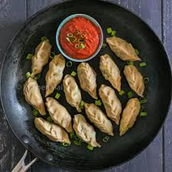 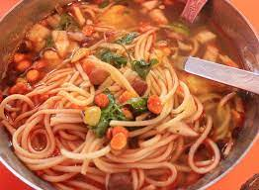

Momo Thupka

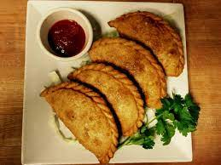 Shaphaley

Then we have the traditional **Nepali thali** (thali means plate). This thali consists of daal (lentil soup) , bhaat (boiled rice), tarkari (vegetable curry), meat curry is served along with pappad and achar (pickles) and something sweet. It is like Bengali and Assamese thali and is served on a big thaal (platter) with small containers. **Aloo achar** is something to look out for in the thali.

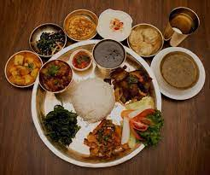 Nepali Thali

Pickles are extremely popular amongst the locals who savor it. One pickle is the **dalle** which is prepared from round red chilli , mustard oil, salt and spices, some artificial preservatives are also added to store it. Another type of pickle favorite amongst the Nepalis is **Kakra ka achar** and **kinema**. It is prepared from cucumber, and can be eaten as either salad or pickle.

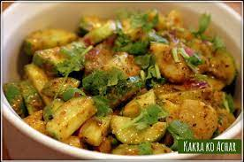 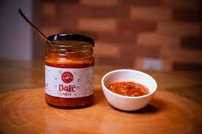

Kakro ka Achar Dalle

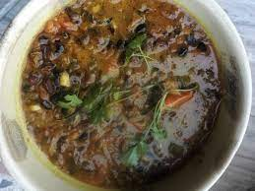 Kinema

**Sael roti** is Nepali dish that is hard to find in the restaurants. It is a kind of bread made of rice paste and deep fried. It is ring shaped and the Nepalis cook it during private ceremonies. **Gundruk** is another famous dish amongst the Nepalis which is prepared from fermented green leafy vegetables.

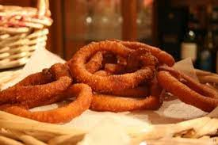 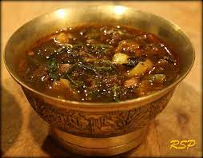

Sael roti. Gundruk.

**Kwati** is a traditional Gorkha cuisine. It is a mixed soup made with nine distinct types of spouted beans. One of the most popular Bengali dish in the town is **Aloo Dum** which has a special place in the hearts of the locals. The perfect blend of spices along with e soft potatoes just hit the right taste bud. **Churpees** are Darjeeling's original snack made out of cows or yak's milk. It resembles cheese and can be both hard and soft.

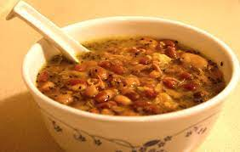 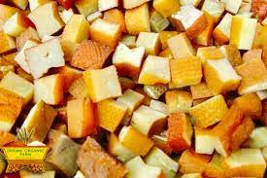

Kwati Churpees

**Chaang** also known as Tongba is a beer like drink prepared by fermenting yeast and warm water is added to the fermented millet. It is enjoyed by the locals on a bamboo container.

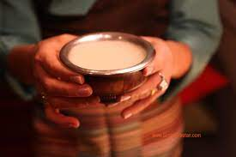 Chaang

Darjeeling is famous for its tea plantation. There are lot of varieties of Darjeeling tea which include green tea, white tea and oolong tea. The warm Darjeeling tea is an absolute pleasure during winters.

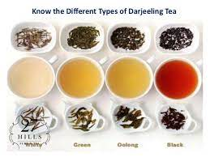 Darjeeling Tea

Darjeeling's food culture along with its breathtaking scenary is a complete win win situation for the tourists who come to this small hill station in search of peace and tranquility in lives.

**Madhusree Purkayastha**

**PYEE**

**MS203701**

TOURIST SPOTS

Darjeeling is a town in India’s West Bengal state ,in the Himalyan foothills and has been recognised as World Heritage site by UNESCO. And it is very much famous for its distinctive black tea and the toy train that has been declared a UN heritage . As it is declared a World Heritage site it ought to have something, a feast to the eye .So here are some tourist spots that we can visit in Darjeeling.

The Darjeeling Himalayan Railway:

The Darjeeling Himalayan Railway also known as the DHR or toy train was declared a World heritage site by UNESCO on december 2, 1999. It was a 2 feet gauge railway that runs between New Jalpaiguri and Darjeeling in the Indian state of West Bengal. It was built between 1879 and 1881 and is about 88km long (55mi). It climbs from about 100m above the sea level at New Jalpaiguri to about 2200m (7218ft) at Darjeeling, using zig zag's and five loops to gain altitude. Six diesel locomotives hand most of the scheduled services , with daily tourist trains from Darjeeling to Ghum -India's highest railway station and the steam hauled 'Red Panda' service from Darjeeling to Kurseong. Steam enthusiast specials are hauled by vintage. British built B class steam locomotives .The railways headquarters is at Kurseong. The Darjeeling Himalayan assets include the stations, line and vehicles. It has nearly 14 stations .

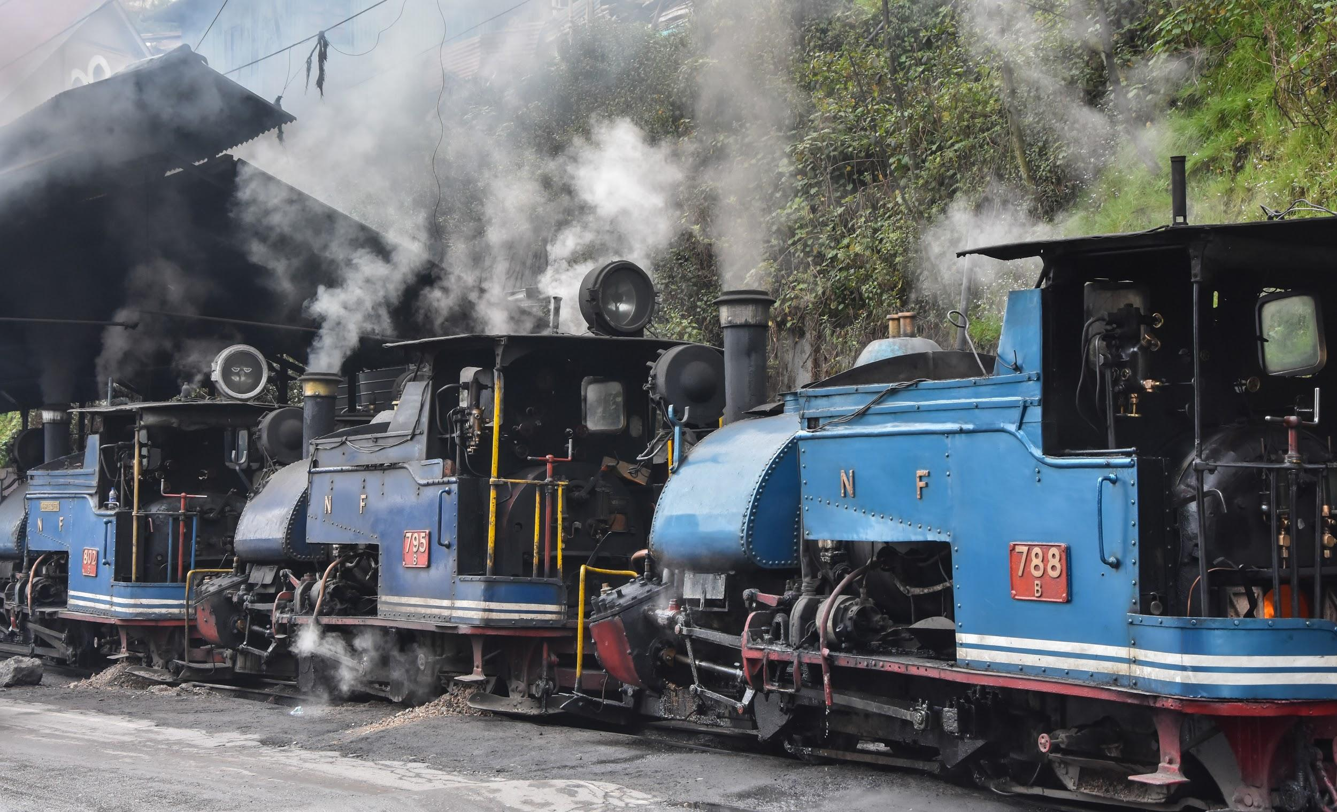

**History:**

It was built by Franklin Prestage an agent of Eastern Bengal railway , he approached the government to lay a steam tramway from Siliguri to Darjeeling. The proposal was accepted in 1879 after a positive report from the committee and construction began that year.By march 1880 track was laid as far as tindharia and its construction was completed in 1881.The railway was closed for 18 months during the Gorkhaland hostilities in 1988 and 1989 .It was declared a world Heritage site by UNESCO in 1999.

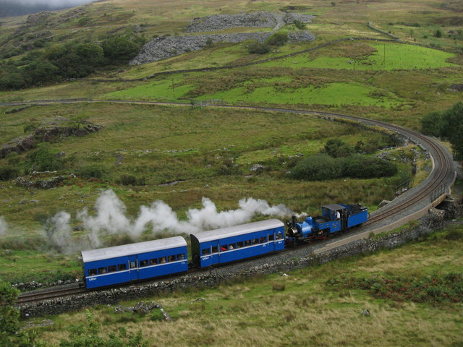

Tiger Hill:

Tiger Hill is located in Darjeeling, in the Indian State of West Bengal.It has an elevation of 2590 m nearly 8500ft. It has a panoramic view of Mount Everest and Kanchenjunga together.From Tiger Hill, Kanchenjunga (8586m) looks higher than Mount Everest , owing to the curvature of the Earth, as it is several miles closer than Mount Everest. It is very much famous for its splendid sights of sunrise where you can see peaks of Kanchenjunga illuminate before the sun at lower elevation. And is always filled with visitors. The best season to see the dazzling snow covered peaks as the sun rises is between mid October to december. March to April is also a good time to watch.One must not miss a splendid view and should visit this place to catch a glimpse of the sun. The Tiger Hill is also called 5062. And is the highest peaks in the area and was the subject of a battle during the 1999 Kargil war.

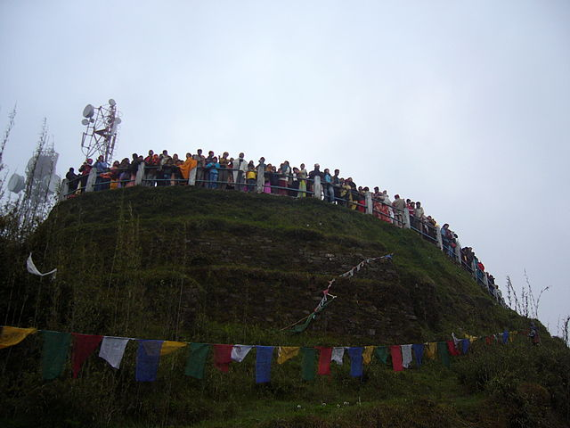

A splendid view from Tiger Hill:

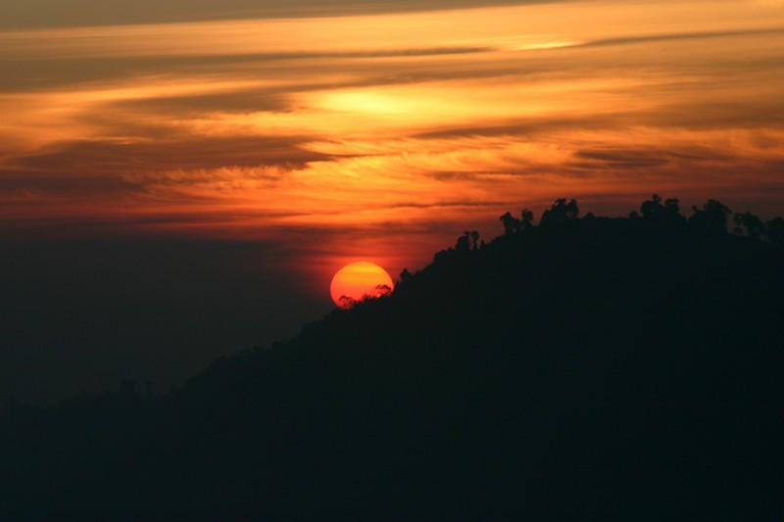

Padmaja Naidu Himalyan Zoological Park:

Padmaja Naidu Himalayan Zoological park is also called as Darjeeling Zoo.It covers a total area of 67.56 acre .The zoo was opened in 1958 and has an average elevation of 7000 feet (2134m),the largest high altitude zoo in India..It specialises in breeding animals adapted to alpine conditions ,and has successful captive breeding programs for the snow leopards that started in 1983 with leopards that were brought to the zoo from Zurich ,the United States and Leh-Ladakh and the critically endangered himalayan wolf and red panda .The red panda program was started in 1994 with individuals from the Cologne Zoo,the Madrid Zoo,Belgium and The Rotterdam zoo.In addition to these species ,the zoo is breeding the Himalyan tahr ,blue sheep,Himalyan monal,grey peacock pheasants ,Himalyan salamander, blood pheasants and satyr tragopan . The zoo attracts nearly 3 lakh visitors every year.The park is named after Padmaja Naidu daughter of Sarojini Naidu.The zoo serves as the central hub for Central Zoo Authority of India’s red panda program and is a member of the World Association of Zoos and Aquariums. The zoo has 156 animals as per the 2006 record.And we ought to visit the zoo one day!

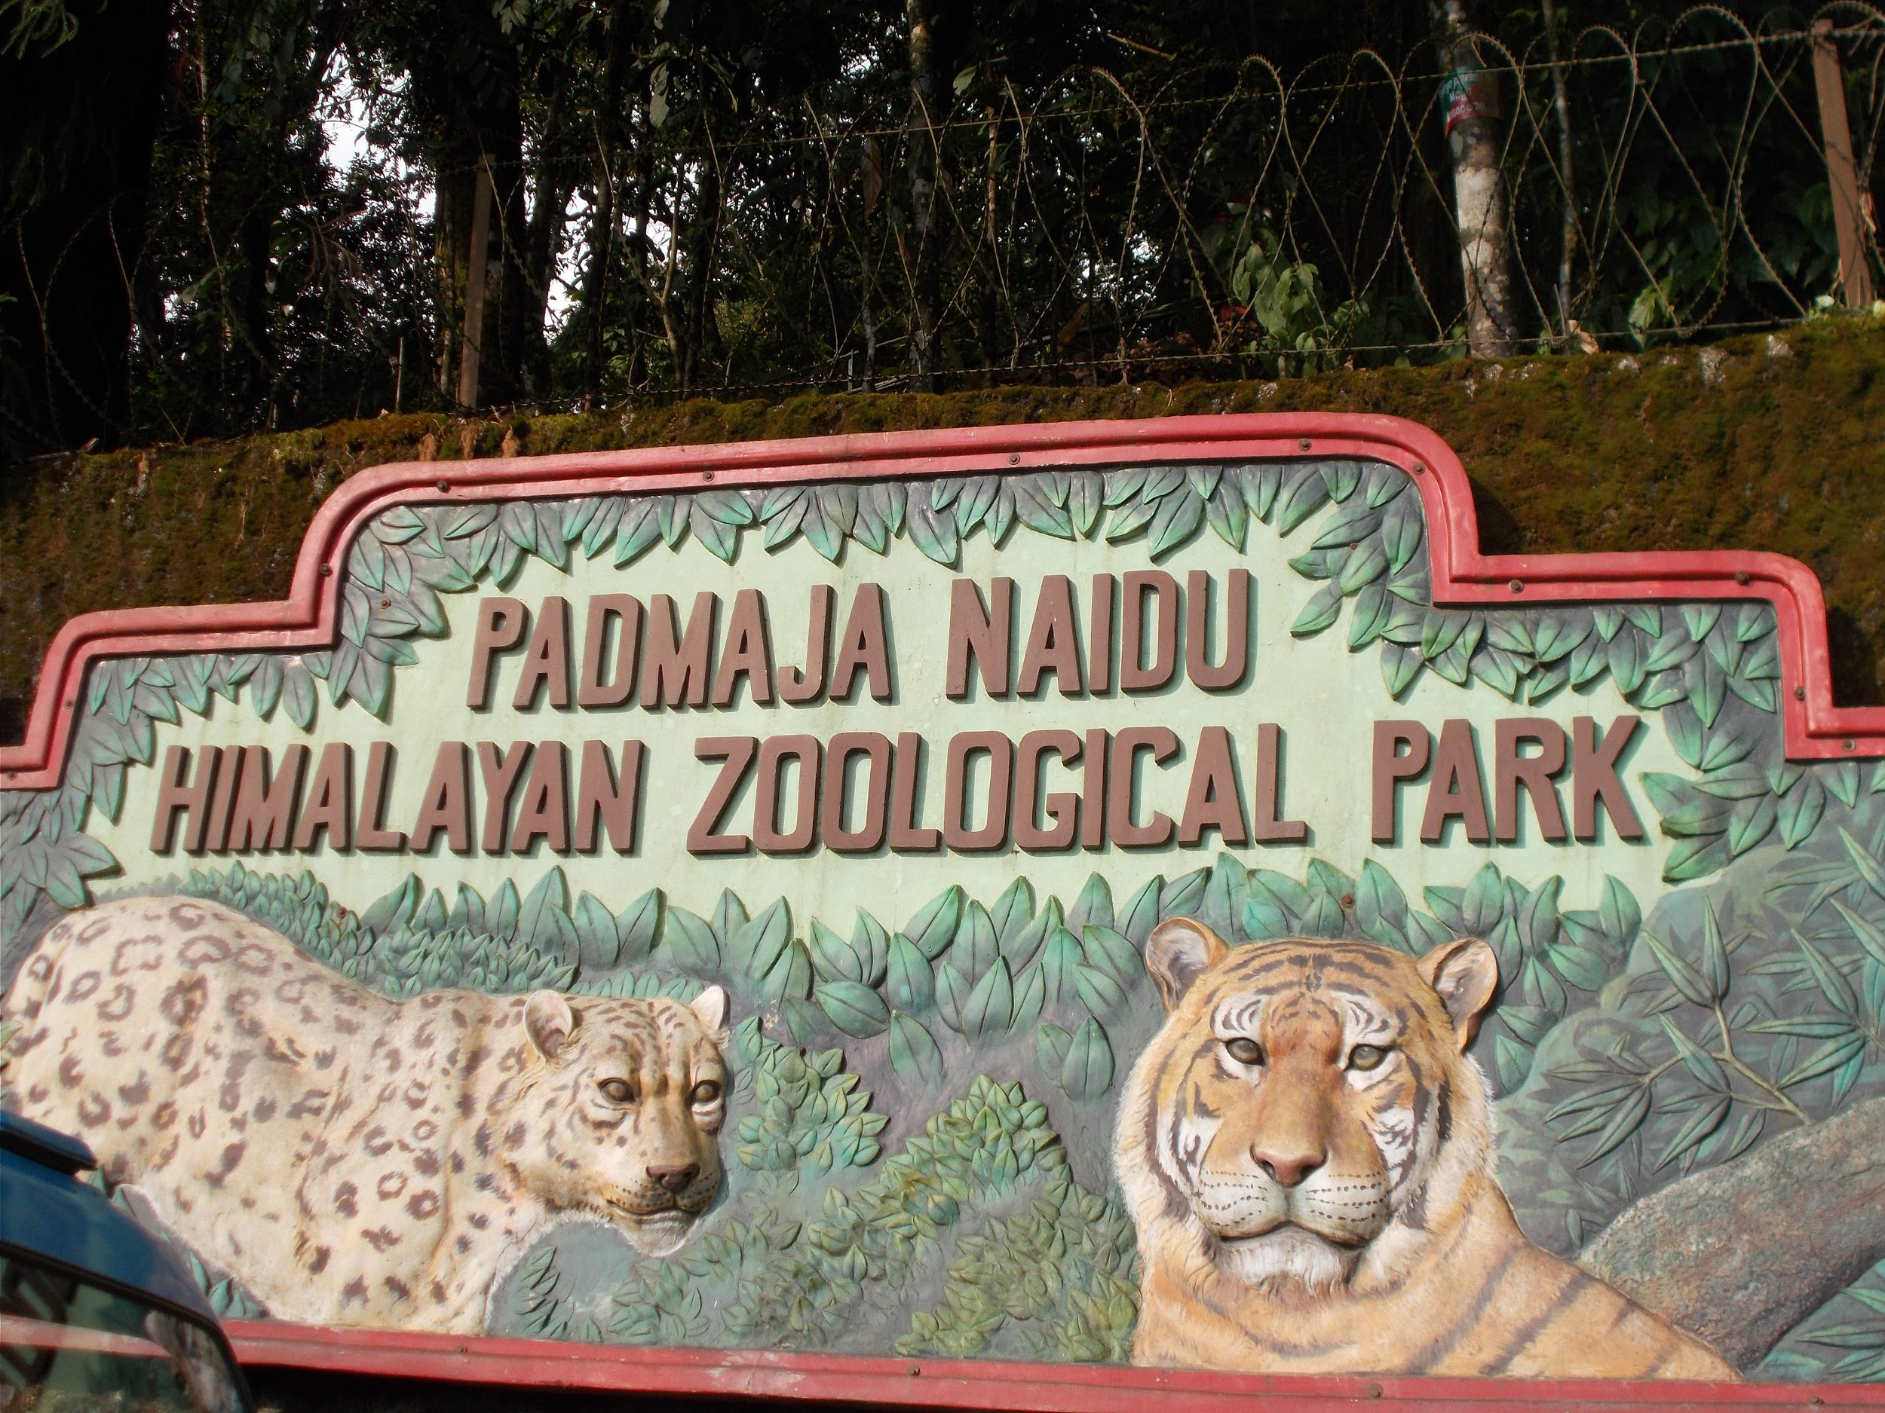

**Sharone Stanly**

**PYEE**

**MA201308**

**Handicraft**

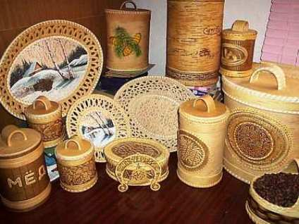

Handicrafts of Darjeeling are well known, for it being a famous tourist spot. Skillful wood/bamboo work, metal work/artefacts, jewellery, paintings, carpets and woollen garments run unparalleled. These unique handicrafts resemble the traditional imprints of Tibetian, Gorkha and Lepcha cultures. These handicrafts originate at the ground level, in the rural areas of Darjeeling. These handicrafts produced make the backbone of the rural economy of the Darjeeling Hills.

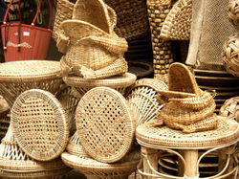

Darjeeling is inhabited by different ethnic groups with distinct identity as well as art and culture. Consequently, the handicrafts of Darjeeling do not follow any set pattern; contrarily, it represents the skills of different groups of artisans. At the same time, it has to be understood that in this modern age when communication has opened up all frontiers, no school of art can live in isolation. That is why although each school strive to retain their individuality, the line of separation has somehow been blurred.  Yet, while discussing the handicrafts of this region, we have divided them under three different sections.

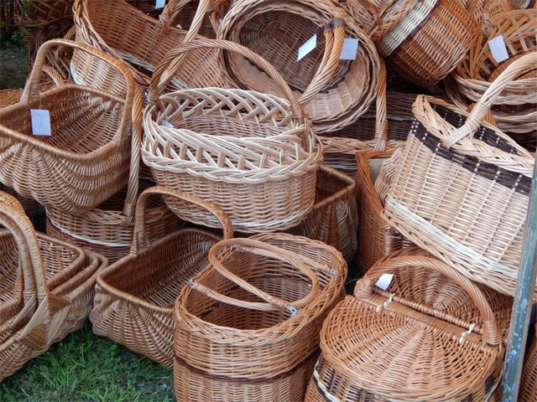

**Market**;

The scenic landscapes and lush valleys of the charming city Darjeeling in West Bengal needs no introduction. With a beautiful view as far as the eye can see, it is undoubtedly one of the best places to explore in summers. While there are so many things to do here, shopping from the various Darjeeling markets are particularly enticing for all shopaholics. From woolens to the exclusive tea, handicrafts, and trinkets, you can find almost everything here.

What makes this place more fascinating is the aroma of Darjeeling tea that lingers in the air just like freshly brewed coffee. The pleasant weather makes sipping a hot cup of tea amidst the stunning hills even better! So, scroll down to know what awaits you in this gorgeous gem.

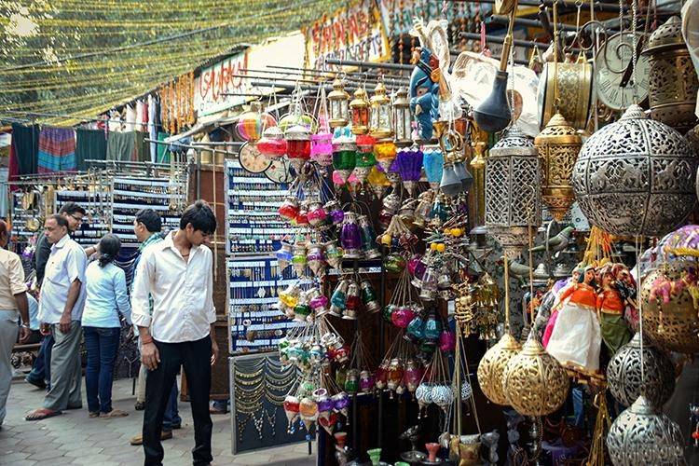

**1. Ghoom Monastery Market**

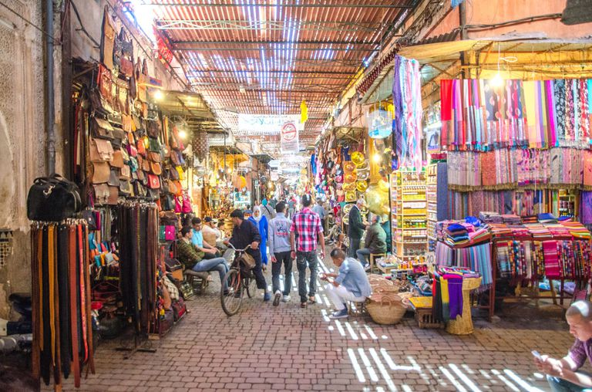

It is said that one must not miss the sunset views from Ghoom Monastery and therefore the perfect time to visit this market would be early mornings or evenings. Take a bite of the sweets that vendors have in the display or choose from a wide range of prayer wheels, wall paintings, bags and singing bowls for your home. The market timings include 9 AM to 7 PM for all visitors.

**2. Nehru Road**

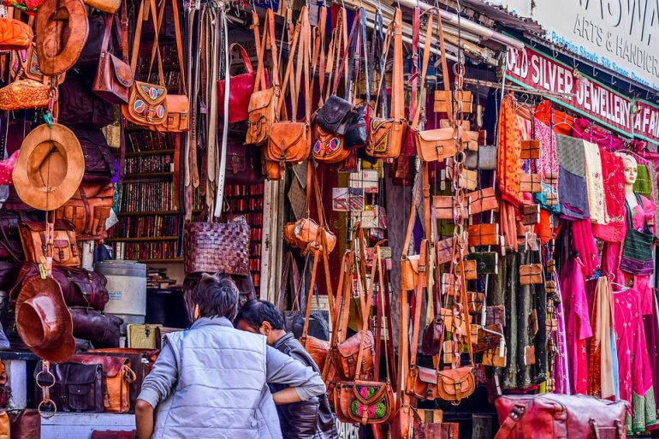

One of the most unique street shopping experiences is offered by Nehru road where locals have set up quaint shops of their own. Since the market is spread across an uphill region of Hill Cart road, walking here will give you hiking goals too. The State government has established a Handicrafts Emporium in recent years and if youre a fan of art and crafts, then this is surely the place to be!

**3. Teesta Bazaar**

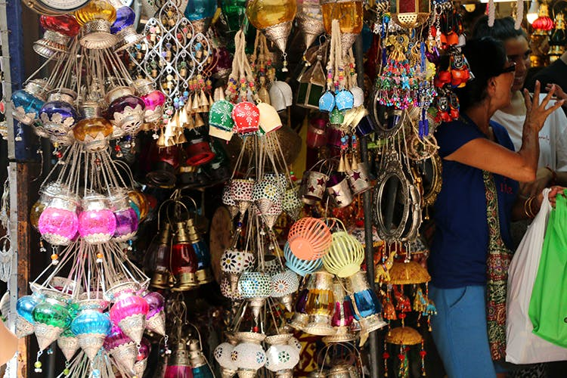

Close to Kalimpong and Melli, Teesta Bazaar offers an extraordinary marketplace for handicrafts with a mesmerizing view of Teesta river on the side. Theres a wide yet unique range of products available at this market such as wall paintings, hunting equipment, copper wares, lanterns, crockery, and footwear. If youre out and about on Siliguri-Gangtok highway heading to Darjeeling, then this market is a must visit for you!

**4. Batasia Loop Market**



Located on the loop line of Ghum and Darjeeling, Batasia Loop is one of the Darjeeling famous markets and has more than apparel and food items to offer. The reasonable prices at which the products are made available here makes it the perfect kind of spot to shop from without stepping out of your budget. The toy-train line starting from this point will add more charm to your overall shopping experience in Darjeeling. With house-decor, accessories and woollens on board, this market opens from 9 AM to 6 PM.

**Shenaha Shree**

**PYEE**

**MA201387**

**Economic and Industrial Development**

The two most significant contributors to Darjeeling's economy are tourism and the tea industry. [Darjeeling tea](https://en.wikipedia.org/wiki/Darjeeling_tea), due to the unique agro-climatic conditions of Darjeeling, has a distinctive natural flavour, is internationally reputed and recognised as a geographical indicator. The tea industry has faced competition in recent years from tea produced in other parts of India as well as other countries like Nepal. Besides tea, the most widely cultivated crops include [maize](https://en.wikipedia.org/wiki/Maize), [millets](https://en.wikipedia.org/wiki/Millets), [paddy](https://en.wikipedia.org/wiki/Rice), [cardamom](https://en.wikipedia.org/wiki/Cardamom), [potato](https://en.wikipedia.org/wiki/Potato) and [ginger](https://en.wikipedia.org/wiki/Ginger).

Darjeeling had become an important tourist destination as early as 1860. It is also a popular filming destination for [Bollywood](https://en.wikipedia.org/wiki/Bollywood) and [Bengali cinema](https://en.wikipedia.org/wiki/Cinema_of_West_Bengal). [Satyajit Ray](https://en.wikipedia.org/wiki/Satyajit_Ray) shot his film [Kanchenjungha](https://en.wikipedia.org/wiki/Kanchenjungha" \o "Kanchenjungha) (1962) here, and his [Feluda](https://en.wikipedia.org/wiki/Feluda" \o "Feluda) series story, Darjeeling Jomjomaat, was also set in the town.[[citation needed](https://en.wikipedia.org/wiki/Wikipedia:Citation_needed)] Bollywood movies such as [Aradhana](https://en.wikipedia.org/wiki/Aradhana_(1969_film)) (1969), [Main Hoon Na](https://en.wikipedia.org/wiki/Main_Hoon_Na) (2004), [Parineeta](https://en.wikipedia.org/wiki/Parineeta_(2005_film)" \o "Parineeta (2005 film)) (2005) and more recently [Barfi!](https://en.wikipedia.org/wiki/Barfi!) (2012) have been filmed here.

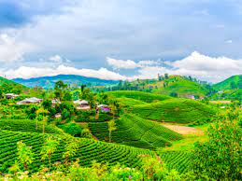

Agriculture in this region is grossly rain dependent and distributed between pre-kharif and kharif seasons. Almost all upper ridges of the region are forest areas; tea plantations and native agriculture occupy mid-hill section. Cultivation of well paddies extends down the mid-hill section up to the bottom valley in some cases.

**Animal Husbandry**:

Livestock plays an important role to uplift the rural economy in our country and more so in the hills. Its contribution in the Gross National Income is about 25%.

**Tourism:**

Tourism is an important economic activity of hill areas of Darjeeling District generating incomes and employment for the local population. Darjeeling receives around 3.5 lakhs domestic tourists and 50,000 foreign tourists per year that generates near 30% of total tourism business of the region worth around Rs 350 crore per annum. Everybody right from a chaiwala upto the hotel owner benefits from the tourism.

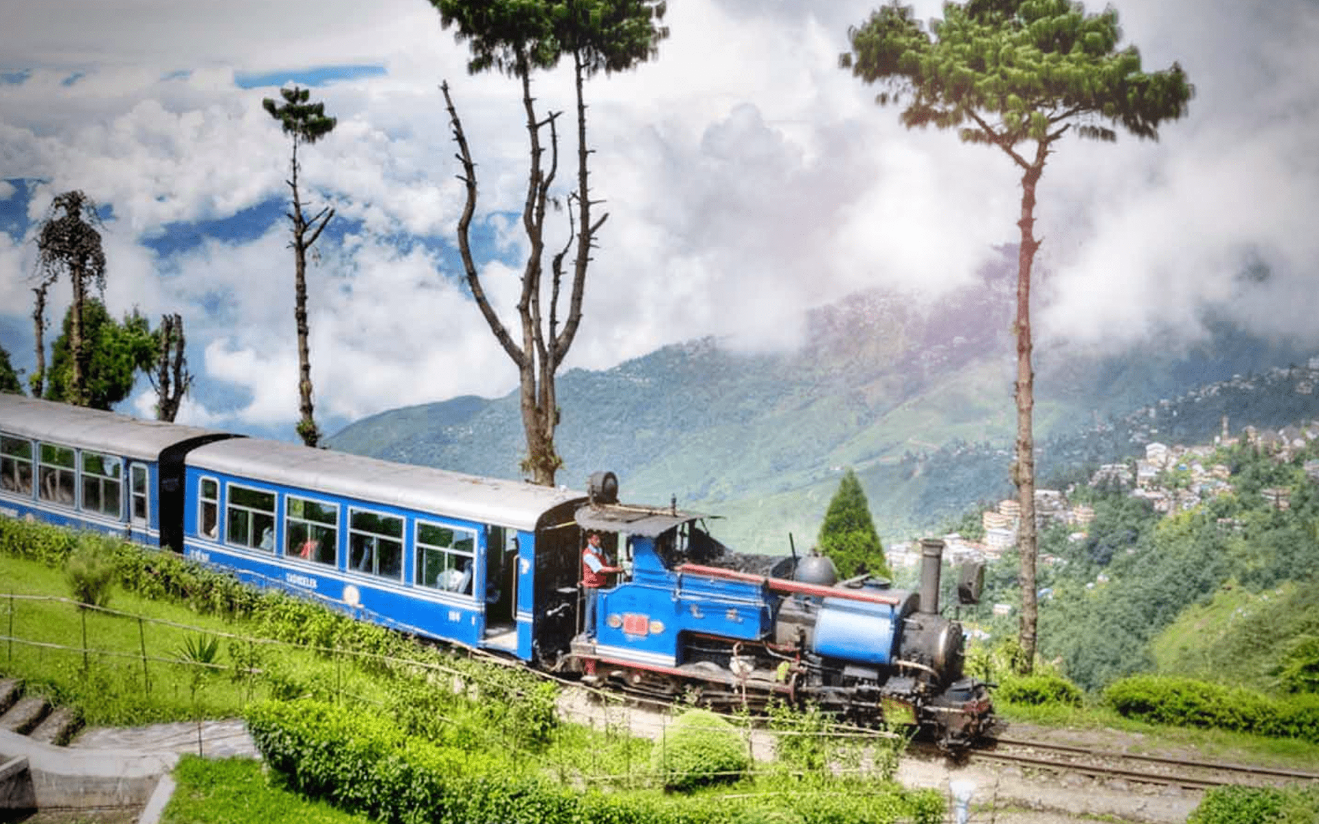

**Tea:**

Darjeeling Hills has been producing finest quality tea in the world fetching the highest price. Starting on a commercial scale in 1856 the present area under Tea Gardens is 19239 hectares producing 11-12 million Kgs. Of tea per year. Cinchona was introduced between 1861 and1869 on trial; large-scale production started from 1887. The best of Indian quality mulberry silk is being produced in Darjeeling hills. Forestry is an important occupation of the people of Darjeeling. Darjeeling has about 38.91 % of its area under forest. Many forest-based industries have come up and there is huge potential for further development.

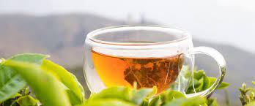

Commercial tea production has been the mainstay of livelihoods and economy in the Darjeeling hills for over 150 years. The Darjeeling tea industry at present employs over 52 thousand people on a permanent basis, while a further 15,000 persons are engaged during the plucking season which lasts from March to November. More than 60 percent are women and the employment is on a family basis.

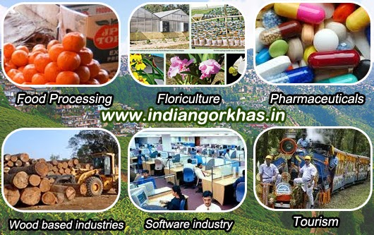**RESOURCE-BASED INDUSTRIES**

**Food Processing**

Darjeeling district alone produces approximately 90,000 tonnes of Pineapple, 20,000 tonnes of Oranges, 80,000 tonnes of Tomato per annum. Besides as much as 6,00,000 nos. of Oranges per day are available in peak season from Sikkim. These huge resources of raw fruits justifies setting up of an integrated plant for producing various items like Orange Squash, Orange Marmalade, Tomato Sauce, Vinegar, Juice, Pineapple rings, Frozen fruits etc.

**Wood based industries**

Large forest cover with abundant supply of wood, bamboo, cane etc. provides excellent opportunity for setting up of industries for manufacture of plywood, veneer, particle board from wood dust etc.

**Rubber Plantation**

Darjeeling district also has ideal conditions for rubber plantation. Setting up of a rubber unit having its own rubber plantation will also encourage the small farmers of surrounding area to take up this activity and sell the rubber milk to the rubber unit.

**SKILL BASED INDUSTRIES**

The artisans of these districts create exquisite varieties of ornaments, carpets, household articles, handicrafts, and other articles, which are widely acclaimed. The traditional cottage industries also include woolen garments, and cane and bamboo work. These cottage and handicraft industries however need proper marketing support through purchase, organising of handicraft exhibitions, formation of societies and guilds etc.

**CONCLUSION**

Owing to high rate of population increase, the per capita agricultural and forest areas have shown a sharp decline. Tourism as an industry is no doubt a part of the socio- economic development of any nation but from the point of view of sustainable development; this industry has been yielding many negative results.Unfortunately, the economic status of rural Darjeeling is very disappointing. Darjeeling is excluded from the industrial map of the country. Surely, the economic viability and environmental feasibility does not welcome the industries. Yet, small and cottage industries that have great potentialities in the region have not been brought in as required. History is a spectator of the amount of neglect faced by the people of the region.

**Chrisweena Jerusha.E**

**PYEE**

**MA201393**